1. Create Temp Folder and Launch Visual Studio

Create a folder on your C:/ drive called temp

Download the zipped file (*) and extract the contents in C:/Temp.

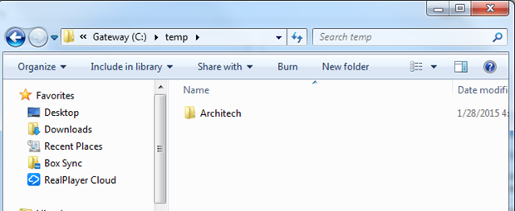

Run Visual Studio and open the solution listed below.

IMPORTANT

Visual Studio has to be launched as Administrator mode to have enough privileges to publish to IIS.

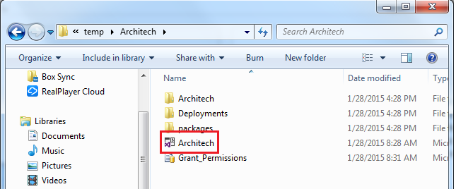

1. Documentation and Deployment Instructions

Documentation regarding this project can be found in the solution.

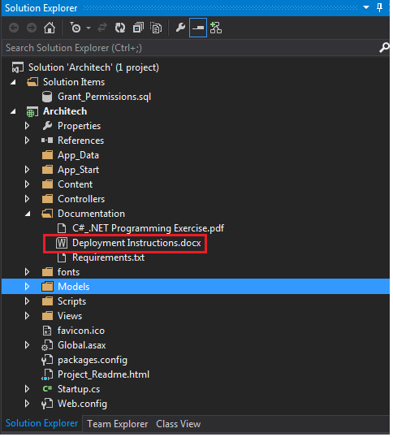

1. Assumptions

Based on the technical constraints provided in C#_.NET Programming Exercise.pdf, the following assumptions were made:

* The source code will be reviewed using Microsoft Visual Studio(1).
* IIS 7.0 or higher is installed on the computer running Visual Studio.
* Web Deploy 3.5 is installed on IIS. A link to download can be found here: http://www.iis.net/downloads/microsoft/web-deploy
* SQL Server Express 2012 is installed on this computer.
* Microsoft .NET Framework 4.5 is installed.
* The user running Visual Studio has administrator rights on this computer.

(1) This application was developed using Visual Studio 2013.

1. Installing IIS

To deploy to IIS on your development computer, you must have IIS and Web Deploy installed. Web Deploy is installed by default with Visual Studio, but IIS is not included in the default Windows 8 or Windows 7 configuration

Using the [Web Platform Installer](http://www.microsoft.com/web/downloads/platform.aspx) is the preferred way to install IIS and Web Deploy, because the Web Platform Installer installs a recommended configuration for IIS and it automatically installs the prerequisites for IIS and Web Deploy if necessary.

To run Web Platform Installer to install IIS and Web Deploy, use the following link. If you already have installed IIS, Web Deploy or any of their required components, the Web Platform Installer installs only what is missing.

* + [Install IIS and Web Deploy using WebPI](http://www.microsoft.com/web/gallery/install.aspx?appsxml=&appid=IIS7;ASPNET;NETFramework4;WDeploy)

You'll see messages indicating that IIS 7 will be installed. The link works for IIS 8 in Windows 8, but for Windows 8 make sure that ASP.NET 4.5 is installed by performing the following steps:

* + Open **Control Panel**, **Programs and Features**, **Turn Windows features on or off**.
  + Expand **Internet Information Services**, **World Wide Web Services**, and **Application Development Features**.
  + Make sure that **ASP.NET 4.5** is selected.

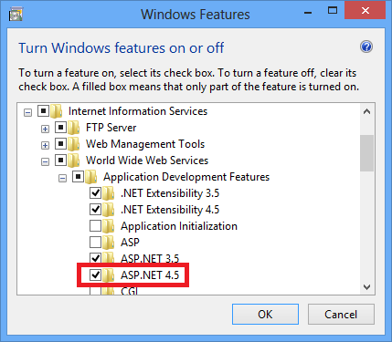

After installing IIS, run **IIS Manager** to make sure that the .NET Framework version 4 is assigned to the default application pool.

1. Press WINDOWS+R to open the **Run** dialog box.

 (Or in Windows 8 enter "run" on the **Start** page, or in Windows 7 select **Run** from the **Start** menu. If **Run** isn't in the **Start** menu, right-click the taskbar, click **Properties**, select the **Start Menu** tab, click **Customize**, and select **Run command**.)

1. Enter "inetmgr", and then click **OK**.
2. In the **Connections** pane, expand the server node and select **Application Pools**. In the **Application Pools**pane, if **DefaultAppPool** is assigned to the .NET framework version 4 as in the following illustration, skip to the next section.

[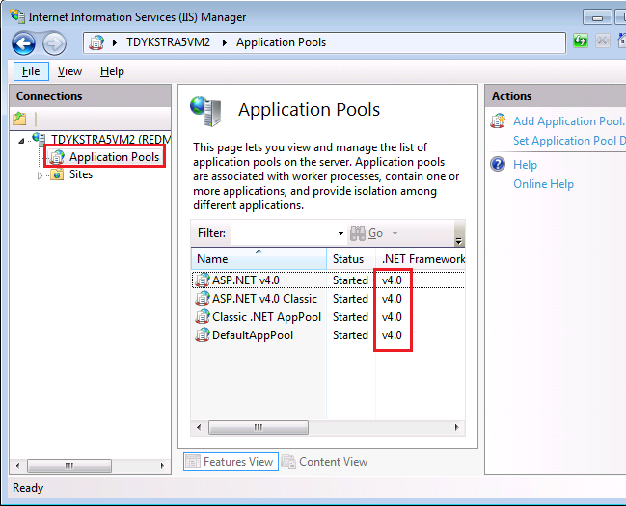](http://i1.asp.net/media/2872817/Windows-Live-Writer_9a5cc04aa344_9D47_Inetmgr_showing_4.0_app_pools_2.png?cdn_id=2015-01-19-002)

1. If you see only two application pools and both of them are set to the .NET Framework 2.0, you have to install ASP.NET 4 in IIS.

For Windows 8, see the instructions in the previous section for making sure that ASP.NET 4.5 is installed, or see[this KB article](http://support.microsoft.com/kb/2736284). For Windows 7, open a command prompt window by right-clicking **Command Prompt** in the Windows **Start** menu and selecting **Run as Administrator**. Then run [aspnet_regiis.exe](http://msdn.microsoft.com/en-us/library/k6h9cz8h.aspx) to install ASP.NET 4 in IIS, using the following commands. (In 32-bit systems, replace "Framework64" with "Framework".)

cd %windir%\Microsoft.NET\Framework64\v4.0.30319

aspnet_regiis.exe –i

This command creates new application pools for the .NET Framework 4, but the default application pool will still be set to 2.0. You'll be deploying an application that targets .NET 4 to that application pool, so you have to change the application pool to .NET 4.

1. If you closed **IIS Manager**, run it again, expand the server node, and click **Application Pools** to display the**Application Pools** pane again.
2. In the **Application Pools** pane, click **DefaultAppPool**, and then in the **Actions** pane click **Basic Settings**.

[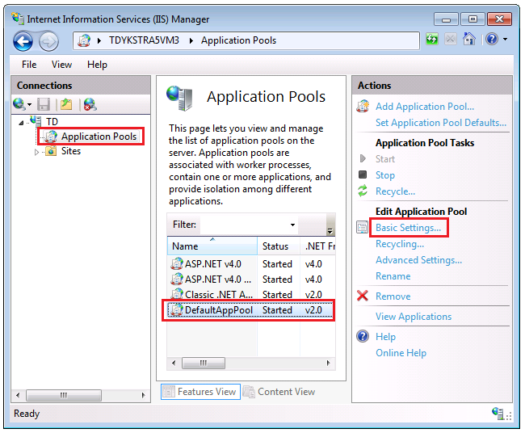](http://i1.asp.net/media/3066894/Windows-Live-Writer_9a5cc04aa344_9D47_Inetmgr_selecting_Basic_Settings_for_app_pool_4.png?cdn_id=2015-01-19-002)

1. In the **Edit Application Pool** dialog box, change **.NET Framework version** to **.NET Framework v4.0.30319**and click **OK**.

[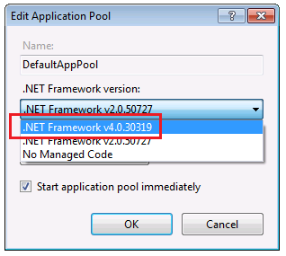](http://i3.asp.net/media/3066906/Windows-Live-Writer_9a5cc04aa344_9D47_Selecting_.NET_4_for_DefaultAppPool_4.png?cdn_id=2015-01-19-002)

IIS is now ready for you to publish a web application to it, but before you can do that you have to create the databases that you will use in the test environment.

1. Install SQL Server Express

To install SQL Server Express, install it from [Download Center: Microsoft SQL Server 2012 Express](http://www.microsoft.com/en-us/download/details.aspx?id=29062) by clicking[ENU\x64\SQLEXPR_x64_ENU.exe](http://download.microsoft.com/download/8/D/D/8DD7BDBA-CEF7-4D8E-8C16-D9F69527F909/ENU/x64/SQLEXPR_x64_ENU.exe) or [ENU\x86\SQLEXPR_x86_ENU.exe](http://download.microsoft.com/download/8/D/D/8DD7BDBA-CEF7-4D8E-8C16-D9F69527F909/ENU/x86/SQLEXPR_x86_ENU.exe). If you choose the wrong one for your system it will fail to install and you can try the other one.

On the first page of the SQL Server Installation Center, click **New SQL Server stand-alone installation or add features to an existing installation**, and follow the instructions, accepting the default choices. In the installation wizard accept the default settings. For more information about installation options, see [Install SQL Server 2012 from the Installation Wizard (Setup)](http://msdn.microsoft.com/en-us/library/ms143219.aspx).

1. Create SQL Server Express databases for the test environment

From the **View** menu select **Server Explorer** (**Database Explorer** in Visual Web Developer), and then right-click**Data Connections** and select **Create New SQL Server Database**.

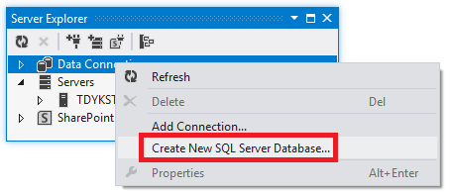

In the **Create New SQL Server Database** dialog box, enter ".\SQLExpress" in the **Server name** box and "Architech" in the **New database name** box, then click **OK**.

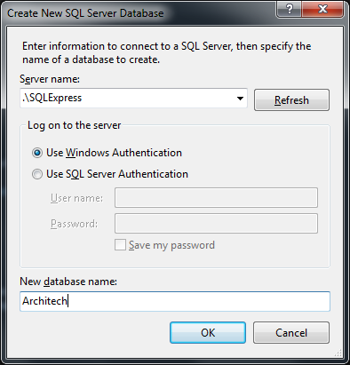

**Server Explorer** now shows the new database (\sqlexpress.Architech.dbo).

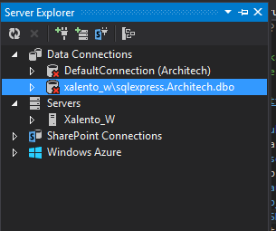

## Run the grant script in the application database

You can configure the publish profile to run the grant script in the membership database during deployment because that database deployment uses the dbDacFx provider. You can't run scripts during Code First Migrations deployment, which is how you're deploying the application database. Therefore, you have to manually run the script before deployment in the application database.

1. In Visual Studio, open the Grant_Permissioins.sql.
2. Click **Connect**,.

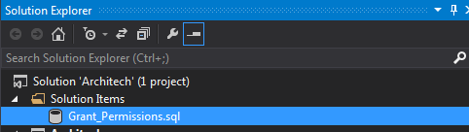

1. In the **Connect to Server** dialog box, enter *.\SQLExpress* as the **Server Name**, and then click **Connect**.
2. In the database drop-down list select **Architech**, and then click **Execute**.

The default application pool identity now has sufficient permissions in the application database for Code First Migrations to create the database tables when the application runs.

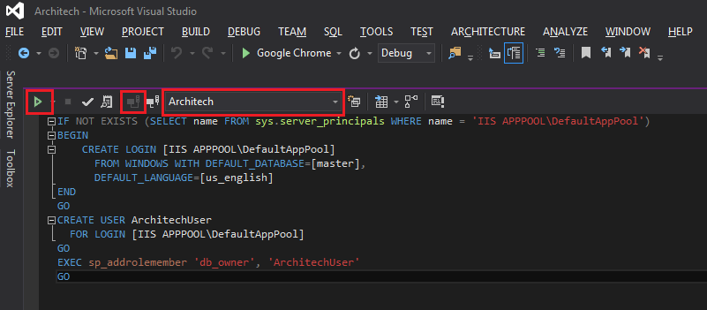

## Publising/Deploying to IIS

This solution uses Web Deploy 3.5 to deploy the application on IIS:

To publish on ISS using **Architech_Web_Deploy**, right click on the **Architech** project node and select **“Publish…”**

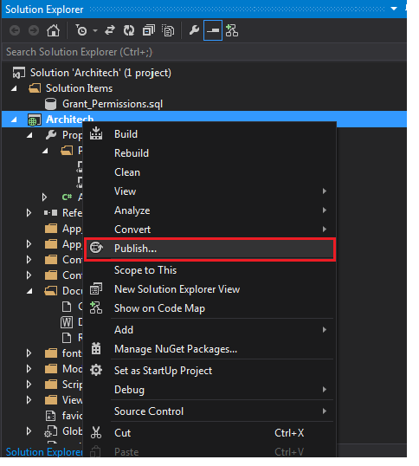

Select **Architech_Web_Deploy** from the Profile dropdown list, and click the **Publish** button**.**

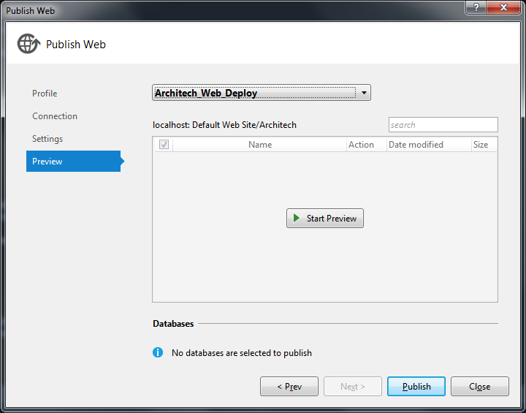

After publishing to IIS, the browser will be launched and the application will start.

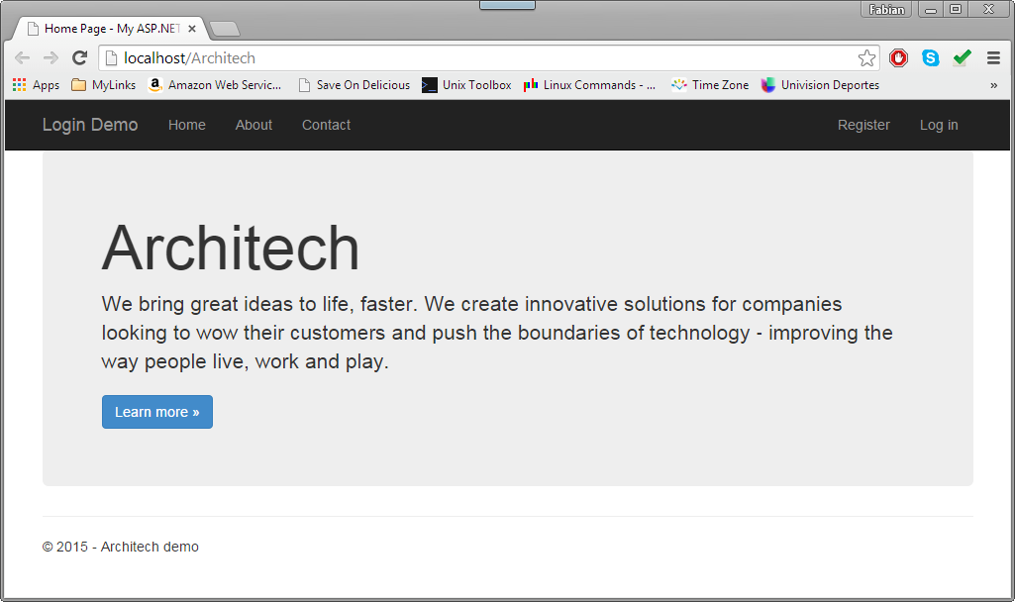

To check the applications deployed in ISS, run ISS manager and expand the Default Web Site.

